UiPath

Doubts:

1. Check once: Priority of queue item will be executed irrespective of the deadline
2. Clone the queue item

======================================================================================

Classic activities

Modern activities-design a project from scratch using this approach

Frequently used activities

Try all properties-Switch, input dialogue, credential manager,

2nd day: https://us01st-cf.zoom.us/web_client/8csbj6s/html/externalLinkPage.html?ref=https://uipath-my.sharepoint.com/:f:/p/rajkumar_mp/ElfnzLNfybZJnh7uG0tp-gwBXjew6rc5XSSE5O8Lt1ua_w?e=LAbE72

Backstage view:

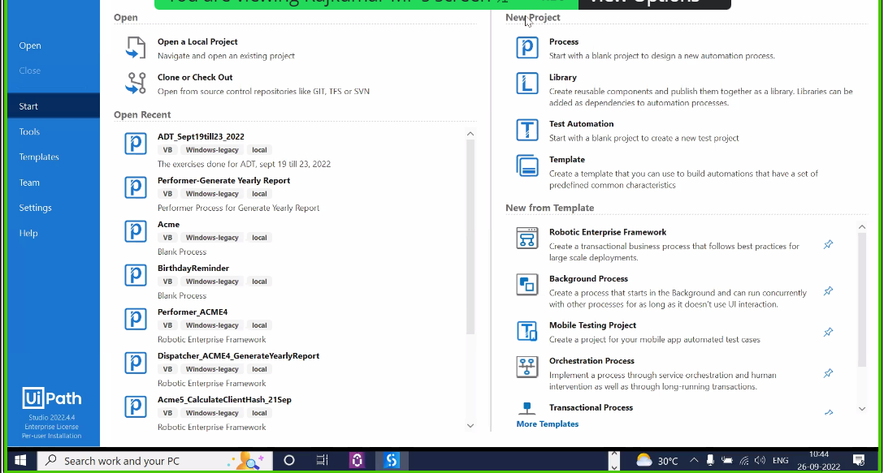

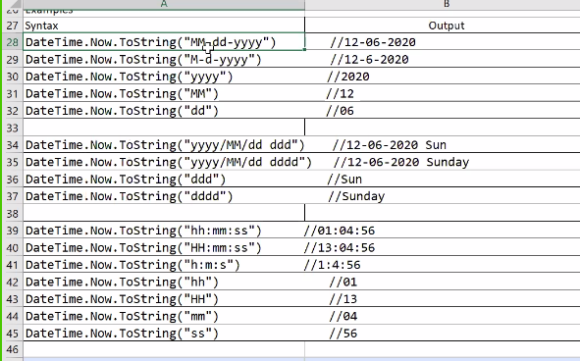

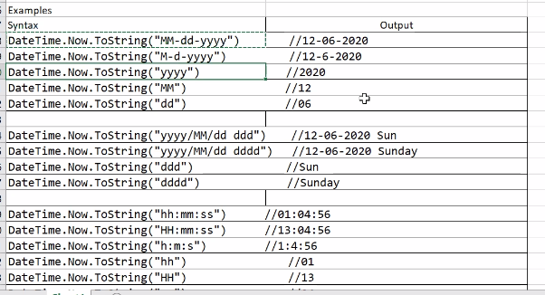

J

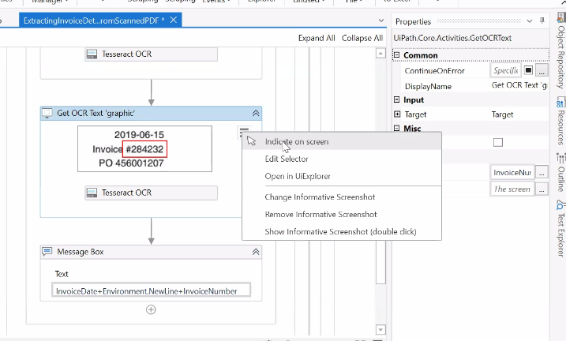

<https://us01st-cf.zoom.us/web_client/8csbj6s/html/externalLinkPage.html?ref=https://uipath-my.sharepoint.com/:f:/p/rajkumar_mp/ElfnzLNfybZJnh7uG0tp-gwBXjew6rc5XSSE5O8Lt1ua_w?e=LAbE72>

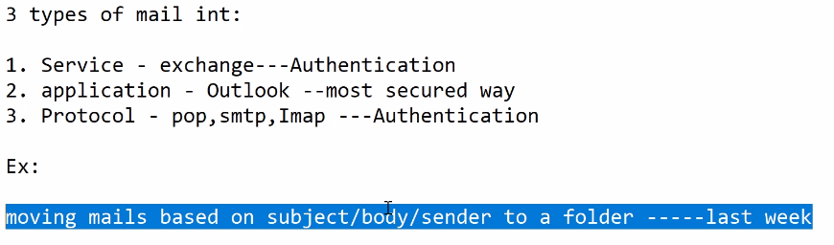

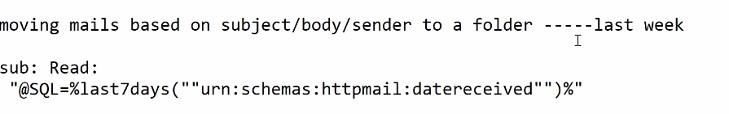

If we give the property TOP= -1, then the entire mails corresponding to the filter is retrieved in the activity “Get outlook mail message”. SO this -1 is not static, it means it is dynamic and not static like positive integer

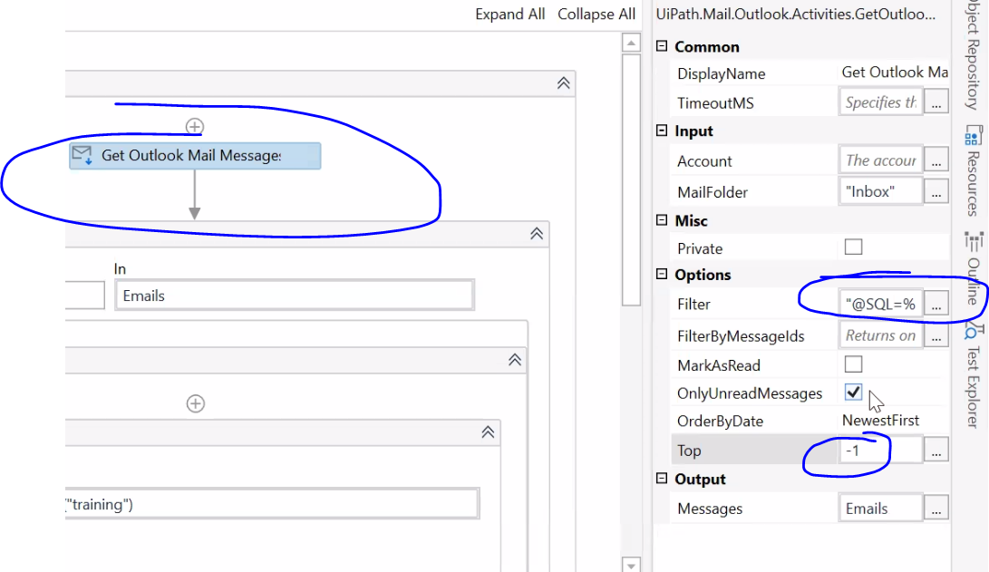

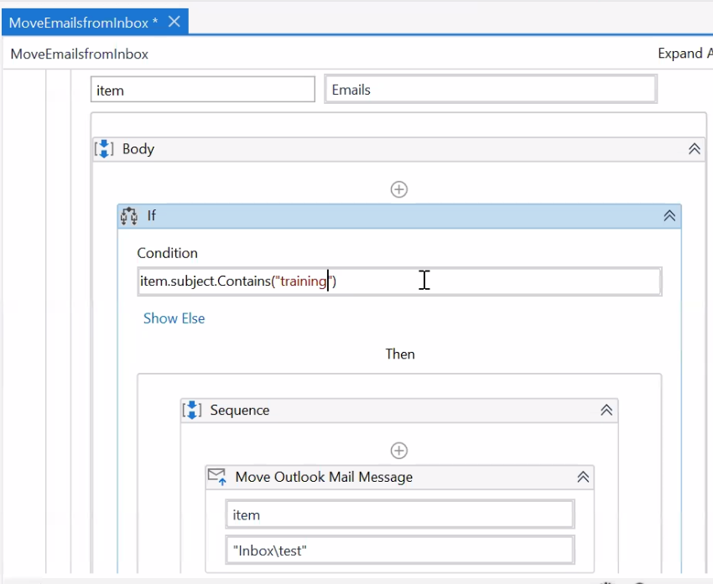

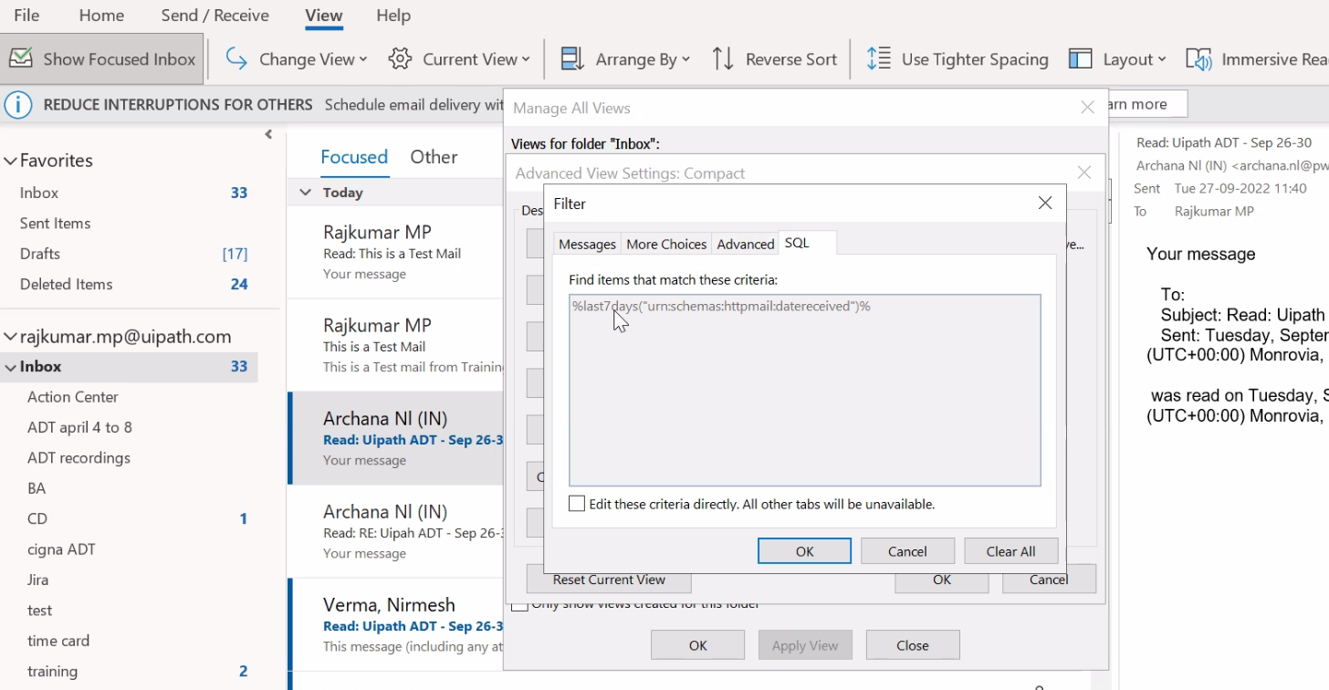 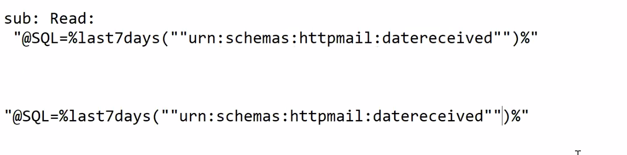

Where ever u have double quotes in the filter criteria, add one more quote like above.

@SQL="”urn:schemas:httpmail:subject"” LIKE '%Test Mail%'

